EXP NO:4a Employee Average Pay

PROGRAM

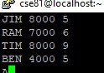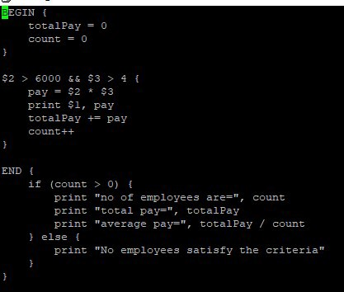

OUTPUT

Adithya.J

230701013 CSE A

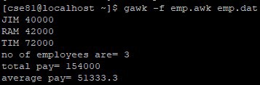

EXP NO:4b Results of Examination

PROGRAM

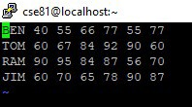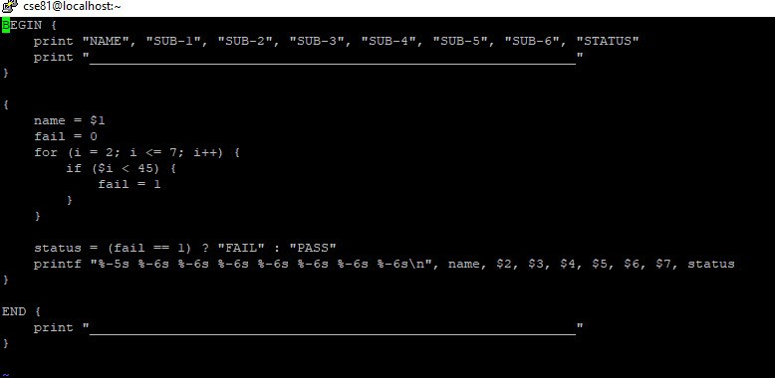

OUTPUT

